*How to save water*

# Introduction

Water your plants early in the morning or late in the evening to reduce water loss due to evaporation. While watering plants, use watering-can instead of a running hose. For watering plants, use waste water that comes off washing of food items.

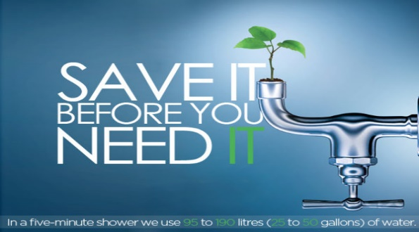

## Some sub topics of water:

Water Topics

* Protect Source Water.
* Save Water with Water Sense.
* Protect Watersheds.
* Volunteer Water Quality Monitoring.
* Urban Water Renewal.

## 2. Key Principles on water saving:

* Water is a stable, versatile molecule. Many organisms live in it, all require it, and most, including humans, are largely made of it. We use water for agriculture, industry, power, retail, residential needs, and direct consumption. About 75 percent of the water we extract from ground and surface is used for irrigation. Water is renewable. It remains in the river after moving the turbines of a hydropower dam, and remains in the soil, air or crops after use in irrigation. It passes through people and animals when they drink it, and through the leaves of plants that pull it up through their roots. Water naturally recycles into the atmosphere and back to the surface through precipitation, and it is cleaned by evaporation and sublimation from surfaces, by plant transpiration, and by respiration. Water also cycles to sugar and back to water again through photosynthesis and respiration.
* The Earth has lots of water on its surface and in the ground just below – 1.4 billion cubic kilometers in total, amounting to 52 billion gallons per person. About 97 percent is seawater, and about 2 percent is locked in ice. Less than one percent is liquid freshwater. Nearly 99 percent of that is groundwater, with a small remainder in lakes and much smaller amounts parceled out to soil moisture, the atmosphere, swamps, rivers, streams, and the bodies of living things. About 400 million gallons of liquid freshwater is present on Earth for each person living – a million times the amount that people use daily. In overall quantity, we have more than enough water.

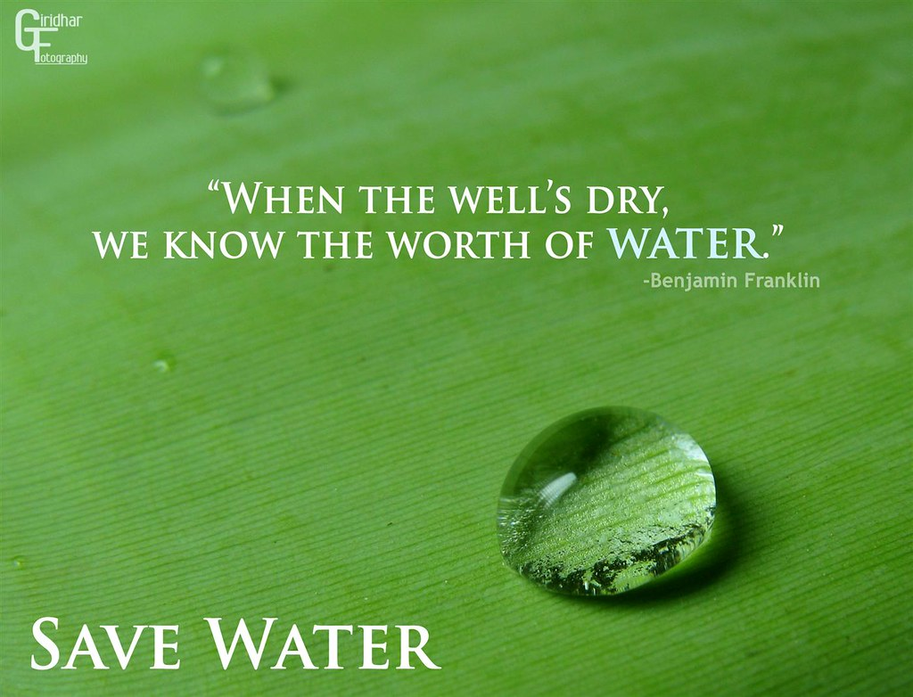

## 3. Some Applications on water saving:

8 useful water conservation apps to help you save water

Table of Contents

Why is saving water so important?

What is a water footprint?

Here are the best apps for saving water:

* Drop counter
* Rain Harvest
* Water Timer
* Drop Drop
* Water1ider
* Water Consumption Calculator
* Water Consumption Calculator by Mr fixIt
* A simple water consumption calculator by Anglian Water

Start saving water today!

Saving water is a very important issue nowadays. Industrial revolution and technological progress cause that we use a lot of water – and this water is necessary not only for human life, but also for other living organisms. Why should we save water? What applications help in water conservation? Take a look at the programs for mobile devices that can come in handy!

On March 22 each year, we celebrate World Water Day. Environmental organizations educate people and businesses about saving water – how to do it and what habits to adopt to waste less water. This is extremely useful knowledge – everyone should know how to save water. Companies, on the other hand, should focus on introducing good practices into their production processes in order to use less water.

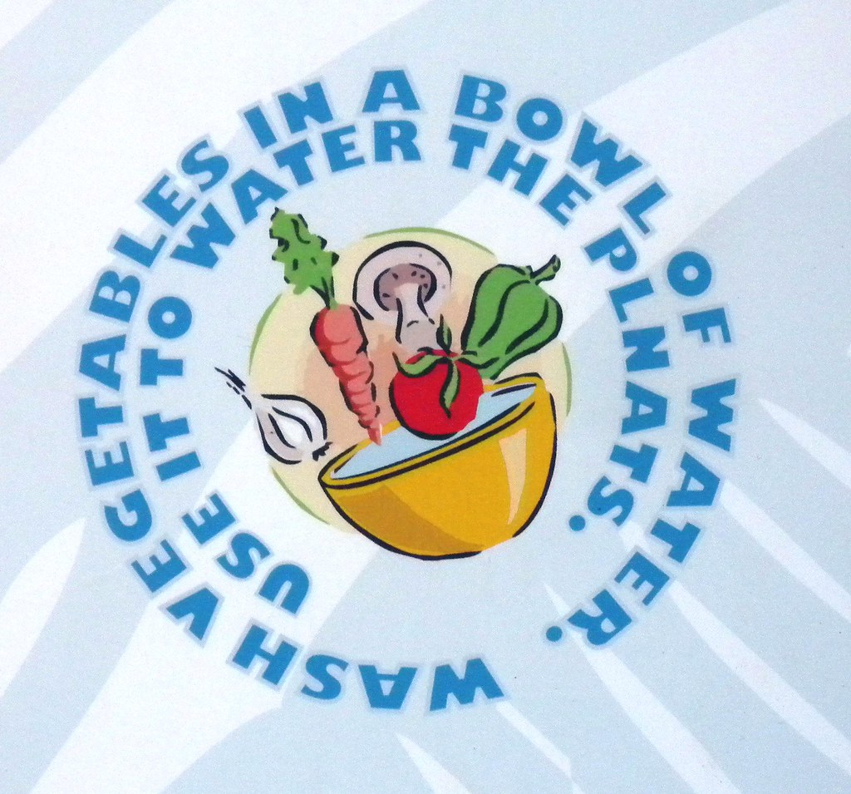

## 4. Current Challenges in how to save water:

* Withdrawals of water to meet urban demands, grow more food, and produce more energy all result in less water for the environment and for maintaining ecosystem health. Our challenge is to identify and then create a sustainable balance among all these demands that are both changing and uncertain.
* Increasing population, industries, generating electricity through reservoirs of dams, rising demands for food and cash crops, increasing urbanization and rising standards of living are the major factors leading to shortages in supply of fresh.
* India lacks proper water management systems, with inefficient irrigation systems, leaky water supply networks, and insufficient wastewater treatment facilities. Climate change has resulted in irregular monsoon patterns and increased frequency of natural disasters, causing further strain on India’s water

## 5. Major Players in how to save water:

Crops resistant to drought

* Fix leaks
* Avoid unnecessary flushing of your toilet
* Clean walkways with a broom
* Take shorter showers
* Turn off the water while shaving
* Wash dishes with consideration
* Water For People
* Water your lawn wisely

## 6. The Future of on saving water:

* By reducing water usage and implementing efficient water-management practices, we can help ensure water resources are available for future generations. Water conservation efforts can include measures such as fixing leaks, using low-flow appliances, and implementing drought-resistant landscaping
* Water usage and availability are critical issues affecting many parts of the world. With growing populations and increasing demands for water, many regions are facing water scarcity and shortages. Changing environmental conditions are exacerbating this problem by altering weather patterns and causing more frequent and severe droughts.
* There are also many strategies for saving water, such as harvesting rainwater, using greywater systems, and recycling wastewater. These approaches can help reduce water usage and preserve this precious resource for future generations

# Conclusion:

In conclusion, water conservation is not a choice but a necessity. Responsible usage in homes, agriculture, and industry, combined with the safeguarding of natural water sources, ensures water’s availability for both current and future generations. This collective effort is indispensable for the survival of our planet.

# References

* 1. Shiklomanov. (1993) Water in Crisis: A Guide to the World’s Freshwater Resources. Oxford University Press, pp. 13.
  2. Supply Concerns Continue, and Uncertainties Complicate Planning. (2014). U.S Government Accountability Office.
  3. United States Environmental Protection Agency. (2016). WaterSense. www3.epa.gov/watersense/index.html
  4. “OECD Glossary of Statistical Terms – Water Conservation Definition.” OECD Glossary of Statistical Terms – Water Conservation Definition. N.p., 25 Sept. 2001. Web. 12 May 2016. <https://stats.oecd.org/glossary/detail.asp?ID=2903>.
  5. Dautremont -Smith, Julian. “How Do Campus Sustainability Initiatives Affect College Admissions? | Association for the Advancement of Sustainability in Higher Education (AASHE).” How Do Campus Sustainability Initiatives Affect College Admissions? | Association for the Advancement of Sustainability in Higher Education (AASHE). The Association for the Advancement of Sustainability in Higher Education (AASHE), 2 Mar. 2009. Web. 12 May 2016.

